**CP Club 365Days Challenge**

**Date – 19/11/2022**

**Programming language – only C language**

**Problem Statement**

**Code must be in C language only**

[https://practice.geeksforgeeks.org/problems/palindrome-string0817/1?page=1&category[]=Strings&sortBy=submissions](https://practice.geeksforgeeks.org/problems/palindrome-string0817/1?page=1&category%5b%5d=Strings&sortBy=submissions)

**Your Code**:

// 0x33Day of 0x365Days challenge

// VEDANT BHARAD

// 19-11-2022

//{ Driver Code Starts

//Initial Template for C

#include <stdio.h>

#include <string.h>

#include <stdbool.h>

// } Driver Code Ends

//User function Template for C

int isPalindrome(char S[])

{

    int con=1,l=strlen(S);

    for(int loop=0;loop<l/2;loop++)

    {

        if(S[loop]!=S[(l-loop)-1])

        {

            con=0;

        }

    }

    return con;

}

//{ Driver Code Starts.

int main()

{

    int t;

    scanf("%d", &t);

    while(t--)

    {

        char s[100000];

        scanf("%s", s);

        printf("%d\n", isPalindrome(s));

    }

    return 0;

}

// } Driver Code Ends

**Output (Screen Shot)**:

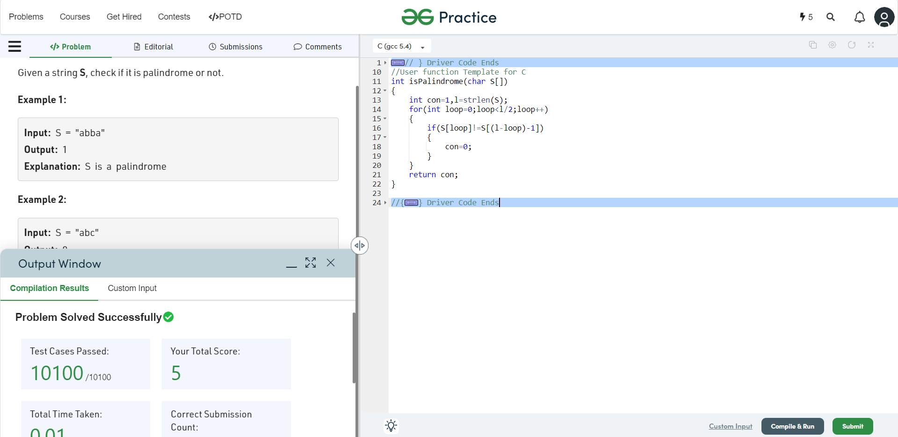

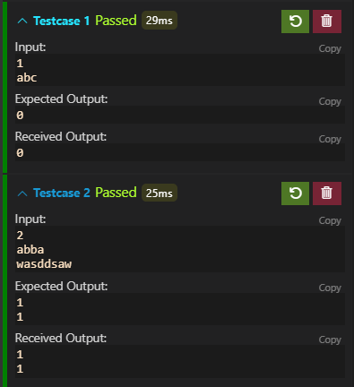

**Understanding about problem:**

* In this task there is one input which is string;
* In this task I need to check the given string is palindrome or not and return 1 if string is palindrome,else return 0;

Note: If you can't understand the problem, feel free to contact us and we'll help you. Please don't copy and paste from anywhere.

ALL THE BEST

Team CP Club